VSWITCH Use-case

The output of CP QUERY VSWITCH <vswitch> DETAILS is a lot of text, I am interrested in the IP addresses in use for each VSWITCH and the user ids that are using them.

The output of the CP QUERY VSWITCH ALL DETAILS command:
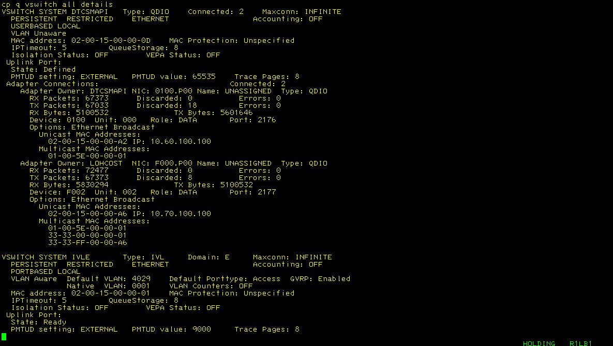
^{Note: long output, suppressed}

Let’s start finding which VSWITCHES we have
/* VS check which vswitches we have */
'PIPE (end ?)',
'cp QUERY VSWITCH ALL', /* Send query 2 CP */
'| pick w1.1 == /VSWITCH/', /* Select these records */
'| cons' /* Show output */

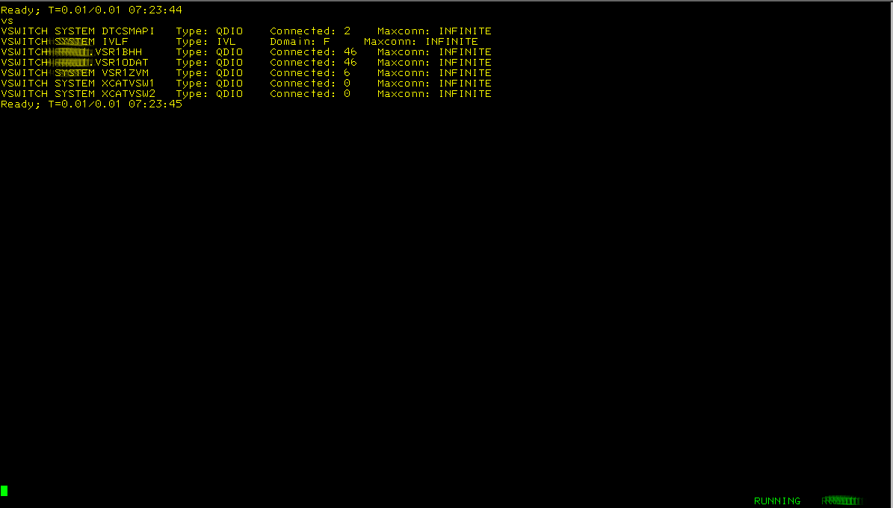

Filtering the switch names from this
/* VS only retain the switch names */
'PIPE (end ?)',
'cp QUERY VSWITCH ALL', /* Send query 2 CP */
'| pick w1.1 == °VSWITCH°', /* Select these records */
'| change / SYSTEM / ./', /* Replace this */
'| specs w2.1 1', /* Keep 2nd word */
'| specs fs . f2', /* Keep 2nd field */
'| cons' /* Show output */

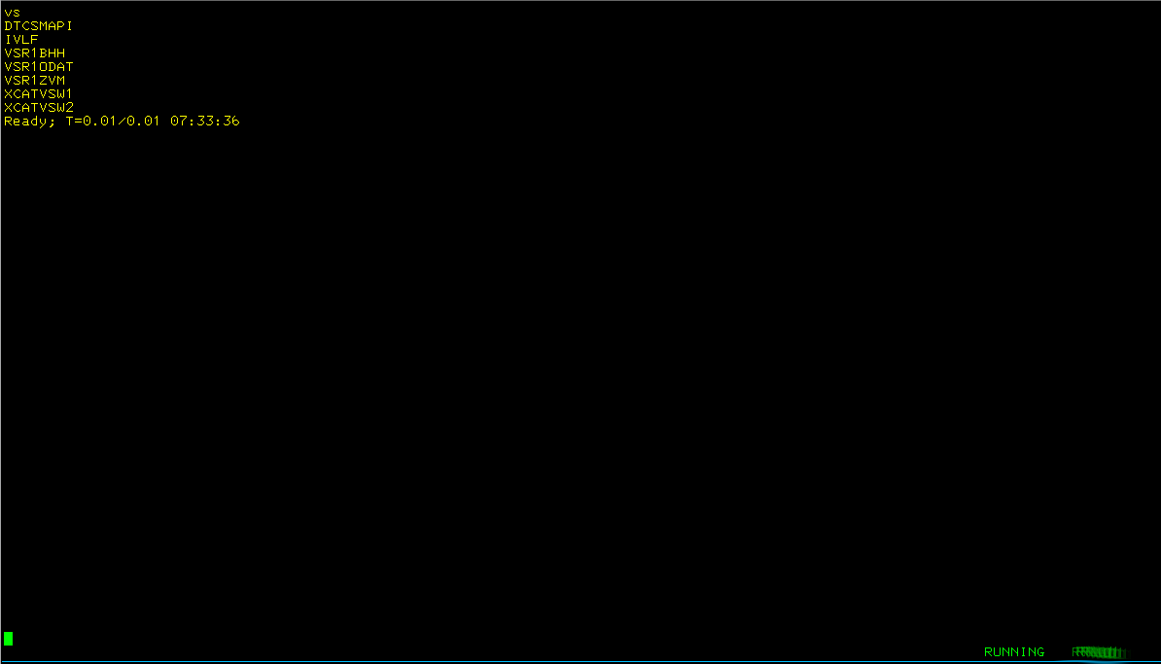

Now we are collecting the details per VSWITCH

/* VS we get more details on the switches */
'PIPE (end ?)',
'cp QUERY VSWITCH ALL', /* Send query 2 CP */
'| pick w1.1 == °VSWITCH°', /* Select these records */
'| change / SYSTEM / ./', /* Replace this */
'| specs w2.1 1', /* Keep 2nd word */
'| specs fs . f2', /* Keep 2nd field */
'| stem vswitch.' /* Store into stem */
Do v=1 To vswitch.0 /* Start my loop */
Say '******* 'vswitch.v /* To separate output */
'PIPE (end ?)',
'cp QUERY VSWITCH 'vswitch.v' DETAILS', /* Ask cp for details */
'| frtarget pick anycase w1.2 == /Adapter Connections:/', /* Take it from here */
'| cons' /* Show results */
End v /* To easily identify the loop */

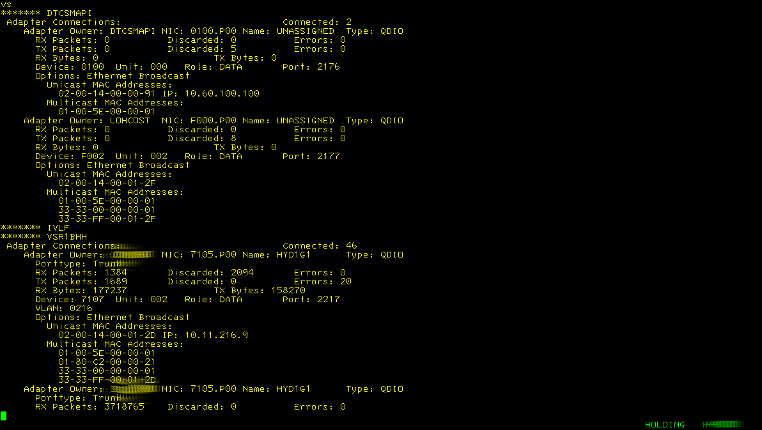
^{Note: long output, suppressed}

Reducing the amount of info we get, by collecting the adapter owners
/* VS retaining the adapter owners */
'PIPE (end ?)',
'cp QUERY VSWITCH ALL', /* Send query 2 CP */
'| pick w1.1 == °VSWITCH°', /* Select these records */
'| change / SYSTEM / ./', /* Replace this */
'| specs w2.1 1', /* Keep 2nd word */
'| specs fs . f2', /* Keep 2nd field */
'| stem vswitch.' /* Store into stem */
Do v=1 To vswitch.0 /* Start my loop */
Say '******* 'vswitch.v /* To separate output */
'PIPE (end ?)',
'cp QUERY VSWITCH 'vswitch.v' DETAILS', /* Ask cp for details */
'| frtarget pick anycase w1.2 == /Adapter Connections:/', /* Take it from here */
'| locate anycase /Adapter Owner/', /* Find these */
'| specs w3.1 1.8 x40 n', /* Keep this from the recordd */
'| cons' /* Show results */
End v /* To easily identify the loop */

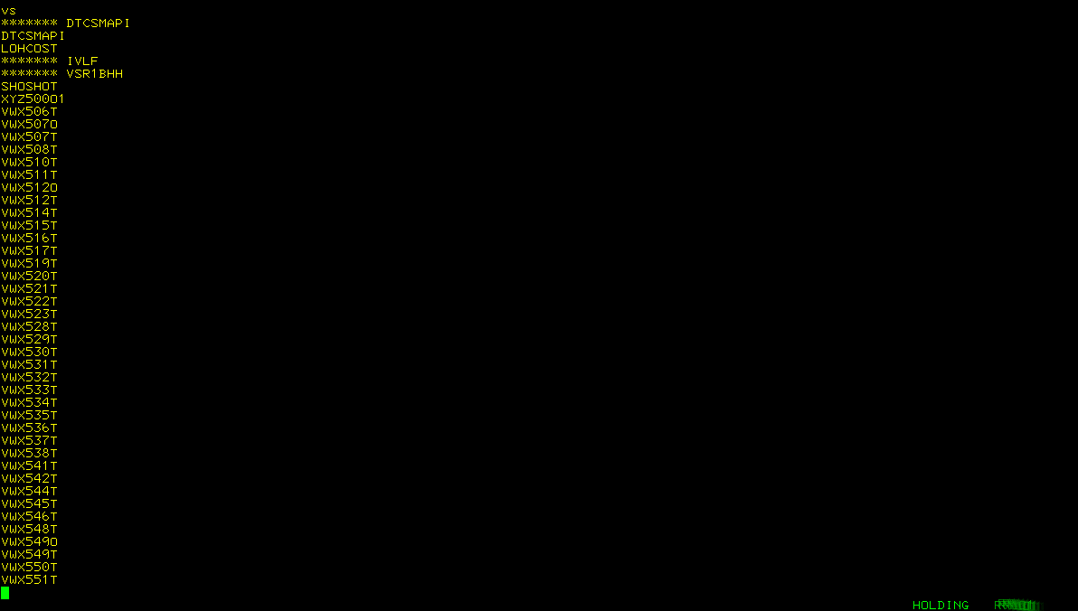
^{Note: long output, suppressed}

Gathering the IP addresses to go with the adapter owner
/* VS gathering IP addresses */
'PIPE (end ?)',
'cp QUERY VSWITCH ALL', /* Send query 2 CP */
'| pick w1.1 == °VSWITCH°', /* Select these records */
'| change / SYSTEM / ./', /* Replace this */
'| specs w2.1 1', /* Keep 2nd word */
'| specs fs . f2', /* Keep 2nd field */
'| stem vswitch.' /* Store into stem */
Do v=1 To vswitch.0 /* Start my loop */
Say '******* 'vswitch.v /* To separate output */
'PIPE (end ?)',
'cp QUERY VSWITCH 'vswitch.v' DETAILS', /* Ask cp for details */
'| frtarget pick anycase w1.2 == /Adapter Connections:/', /* Take it from here */
'| fo1: fanout', /* Duplicate to fo1 label */
'| locate anycase /Adapter Owner/', /* Find these */
'| specs w3.1 1.8 x40 n', /* Keep this from the recordd */
'| cons', /* Show results */
'? fo1:', /* Label connecting to fanout*/
'| strip', /* Remove spaces */
'| inside anycase /UNICAST MAC/ /MULTICAST MAC/', /* Sel. records between these strings */
'| specs w3.1 1 x40 n', /* Keep this bit and add a space */
'| cons' /* Show results */
End v /* To easily identify the loop */
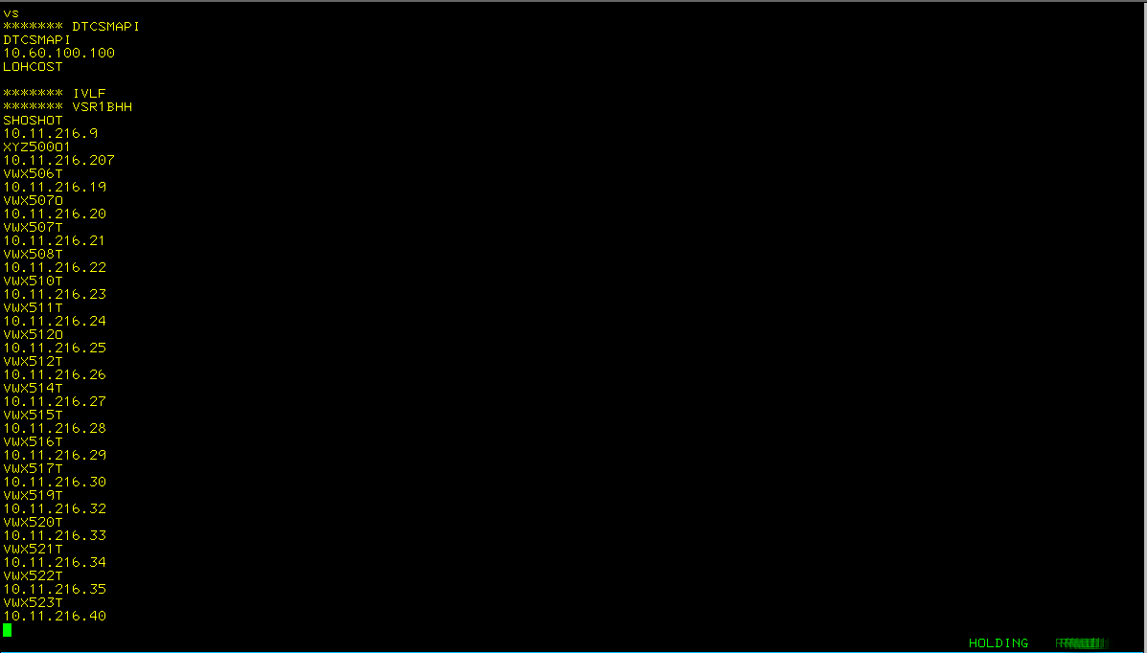
^{Note: long output, suppressed}

Joining the adapter owner and its ip addresses
/* VS join adapter owner and IP addresses */
'PIPE (end ?)',
'cp QUERY VSWITCH ALL', /* Send query 2 CP */
'| pick w1.1 == °VSWITCH°', /* Select these records */
'| change / SYSTEM / ./', /* Replace this */
'| specs w2.1 1', /* Keep 2nd word */
'| specs fs . f2', /* Keep 2nd field */
'| stem vswitch.' /* Store into stem */
Do v=1 To vswitch.0 /* Start my loop */
Say '******* 'vswitch.v /* To separate output */
'PIPE (end ?)',
'cp QUERY VSWITCH 'vswitch.v' DETAILS', /* Ask cp for details */
'| frtarget pick anycase w1.2 == /Adapter Connections:/', /* Take it from here */
'| fo1: fanout', /* Duplicate to fo1 label */
'| locate anycase /Adapter Owner/', /* Find these */
'| specs w3.1 1.8 x40 n', /* Keep this from the recordd */
'| j: juxtapose', /* Join records side by side */
'| cons', /* Show results */
'? fo1:', /* Label connecting to fanout*/
'| strip', /* Remove spaces */
'| inside anycase /UNICAST MAC/ /MULTICAST MAC/', /* Sel. records between these strings */
'| specs w3.1 1 x40 n', /* Keep this bit and add a space */
'| j:' /* Feed records to juxtapose */
End v /* To easily identify the loop */
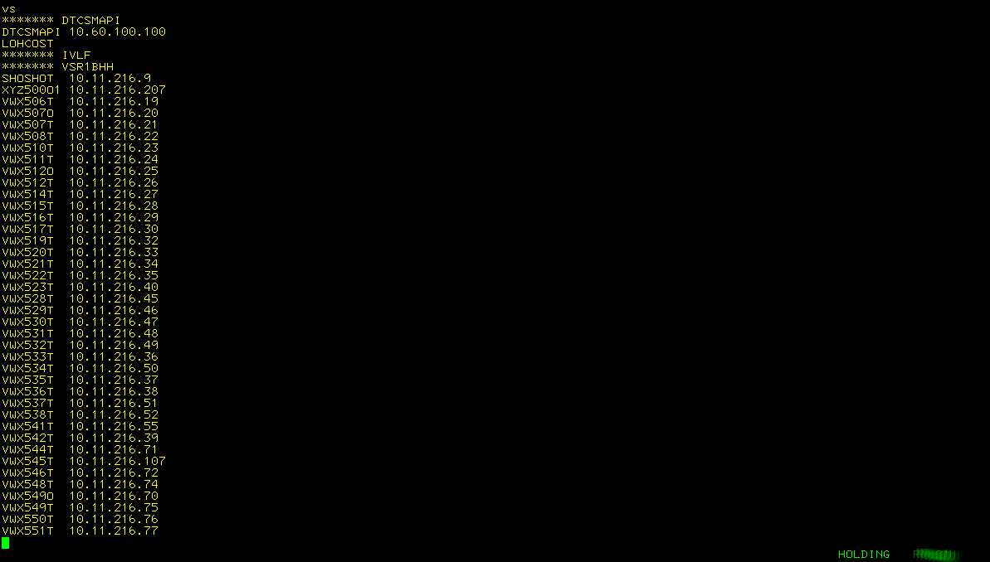
^{Note: long output, suppressed}

Gather the IP addresses per owner
/* VS adapter owners have more than 1 IP addresses, make 1 record per owner */
'PIPE (end ?)',
'cp QUERY VSWITCH ALL', /* Send query 2 CP */
'| pick w1.1 == °VSWITCH°', /* Select these records */
'| change / SYSTEM / ./', /* Replace this */
'| specs w2.1 1', /* Keep 2nd word */
'| specs fs . f2', /* Keep 2nd field */
'| pick 1.3 == °VSR° and 5.1 == °O°', /* To make sure we can capture the result */
'| stem vswitch.' /* Store into stem */
Do v=1 To vswitch.0 /* Start my loop */
Say '******* 'vswitch.v /* To separate output */
'PIPE (end ?)',
'cp QUERY VSWITCH 'vswitch.v' DETAILS', /* Ask cp for details */
'| frtarget pick anycase w1.2 == /Adapter Connections:/', /* Take it from here */
'| fo1: fanout', /* Duplicate to fo1 label */
'| locate anycase /Adapter Owner/', /* Find these */
'| specs w3.1 1.8 x40 n', /* Keep this from the recordd */
'| j: juxtapose', /* Join records side by side */
'| join keylen 8', /* Join so we see more than 1 IP address */
'| cons', /* Show results */
'? fo1:', /* Label connecting to fanout*/
'| strip', /* Remove spaces */
'| inside anycase /UNICAST MAC/ /MULTICAST MAC/', /* Sel. records between these strings */
'| specs w3.1 1 x40 n', /* Keep this bit and add a space */
'| j:' /* Feed records to juxtapose */
End v /* To easily identify the loop */

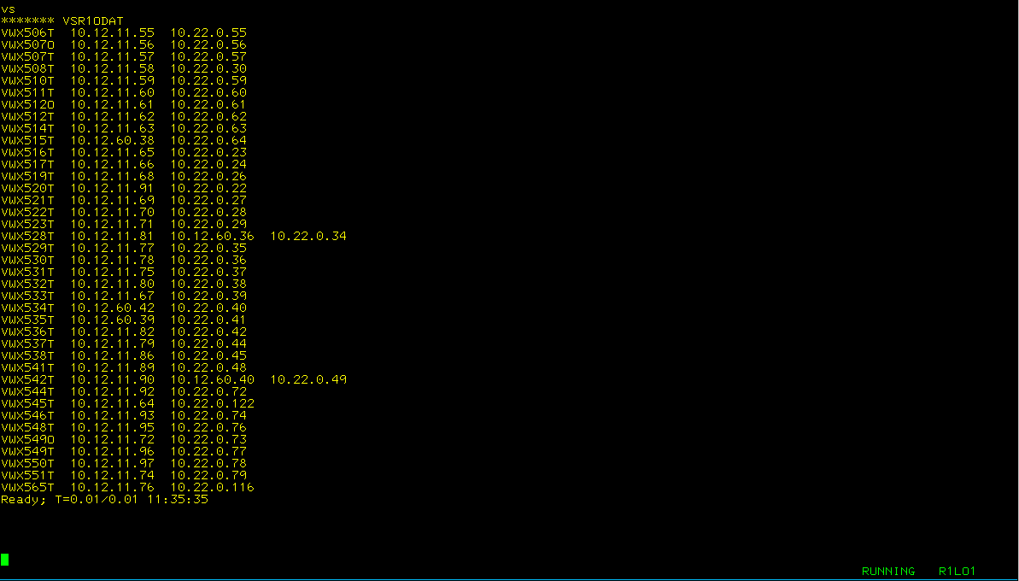
^{Note: long output, suppressed}

Now we are adding counts for the user ids connected to the VSWITCH
/* VS adding a count for the users connected to the switch */
'PIPE (end ?)',
'cp QUERY VSWITCH ALL', /* Send query 2 CP */
'| pick w1.1 == °VSWITCH°', /* Select these records */
'| change / SYSTEM / ./', /* Replace this */
'| specs w2.1 1', /* Keep 2nd word */
'| specs fs . f2', /* Keep 2nd field */
'| pick 1.3 == °VSR° and 5.1 == °O°', /* To make sure we can capture the result */
'| stem vswitch.' /* Store into stem */
Do v=1 To vswitch.0 /* Start my loop */
Say '******* 'vswitch.v /* To separate output */
'PIPE (end ?)',
'cp QUERY VSWITCH 'vswitch.v' DETAILS', /* Ask cp for details */
'| frtarget pick anycase w1.2 == /Adapter Connections:/', /* Take it from here */
'| fo1: fanout', /* Duplicate to fo1 label */
'| locate anycase /Adapter Owner/', /* Find these */
'| specs w3.1 1.8 x40 n', /* Keep this from the recordd */
'| j: juxtapose', /* Join records side by side */
'| join keylen 8', /* Join so we see more than 1 IP address */
'| fo2: fanout', /* Send records 2 label fo2 */
'| fi: faninany', /* Take records from fi labels */
'| cons', /* Show results */
'? fo1:', /* Label connecting to fanout*/
'| strip', /* Remove spaces */
'| inside anycase /UNICAST MAC/ /MULTICAST MAC/', /* Sel. records between these strings */
'| specs w3.1 1 x40 n', /* Keep this bit and add a space */
'| j:', /* Feed records to juxtapose */
'? fo2:', /* Take records from fanout */
'| specs w1.1 1', /* Keep only user id */
'| count lines', /* Count the lines */
'| specs /'vswitch.v' * No of servers found/ 1 w1.1 nw', /* Add some text */
'| fi:' /* Send records 2 faninany */
End v /* To easily identify the loop */

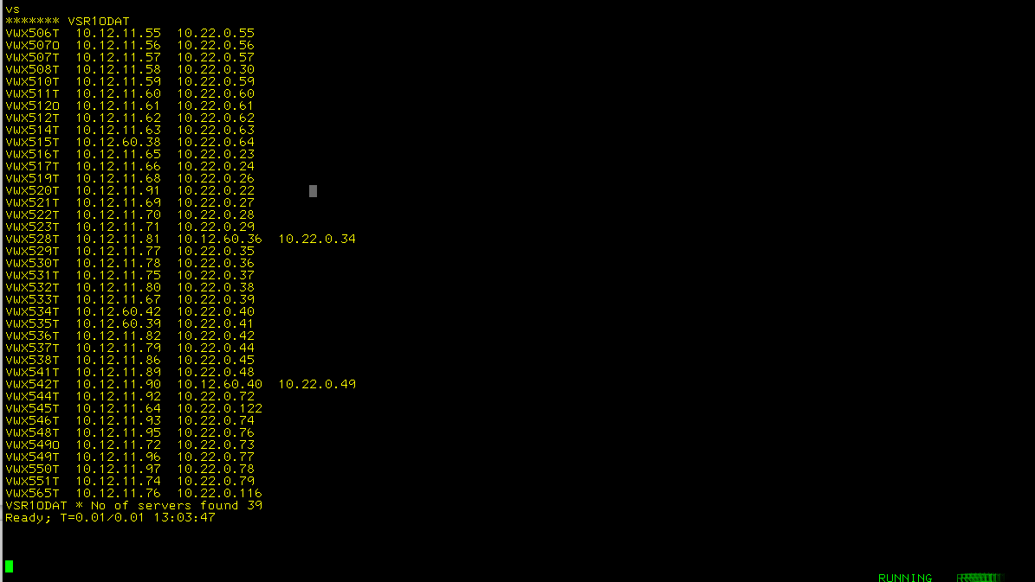
Note: output limited to 1 VSWITCH, see code

Here we add the count for the number of IP addresses in use on the VSWITCH
/* VS adding a count for the ip addresses on the switch */
'PIPE (end ?)',
'cp QUERY VSWITCH ALL', /* Send query 2 CP */
'| pick w1.1 == °VSWITCH°', /* Select these records */
'| change / SYSTEM / ./', /* Replace this */
'| specs w2.1 1', /* Keep 2nd word */
'| specs fs . f2', /* Keep 2nd field */
'| pick 1.3 == °VSR° and 5.1 == °O°', /* To make sure we can capture the result */
'| stem vswitch.' /* Store into stem */
Do v=1 To vswitch.0 /* Start my loop */
Say '******* 'vswitch.v /* To separate output */
'PIPE (end ?)',
'cp QUERY VSWITCH 'vswitch.v' DETAILS', /* Ask cp for details */
'| frtarget pick anycase w1.2 == /Adapter Connections:/', /* Take it from here */
'| fo1: fanout', /* Duplicate to fo1 label */
'| locate anycase /Adapter Owner/', /* Find these */
'| specs w3.1 1.8 x40 n', /* Keep this from the recordd */
'| j: juxtapose', /* Join records side by side */
'| join keylen 8', /* Join so we see more than 1 IP address */
'| fo2: fanout', /* Send records 2 label fo2 */
'| fi: faninany', /* Take records from fi labels */
'| cons', /* Show results */
'? fo1:', /* Label connecting to fanout*/
'| strip', /* Remove spaces */
'| inside anycase /UNICAST MAC/ /MULTICAST MAC/', /* Sel. records between these strings */
'| specs w3.1 1 x40 n', /* Keep this bit and add a space */
'| j:', /* Feed records to juxtapose */
'? fo2:', /* Take records from fanout */
'| specs w1.1 1', /* Keep only user id */
'| count lines', /* Count the lines */
'| specs /'vswitch.v' * No of servers found/ 1 w1.1 nw', /* Add some text */
'| fi:', /* Send records 2 faninany */
'? fo2:', /* Take records from fo2 */
'| specs w2;* 1', /* Keep ip addresses */
'| count words', /* Count them */
'| specs /'vswitch.v' * No of user ids found/ 1 w1.1 nw', /* Add text */
'| fi:' /* Connect to faninany */
End v /* To easily identify the loop */

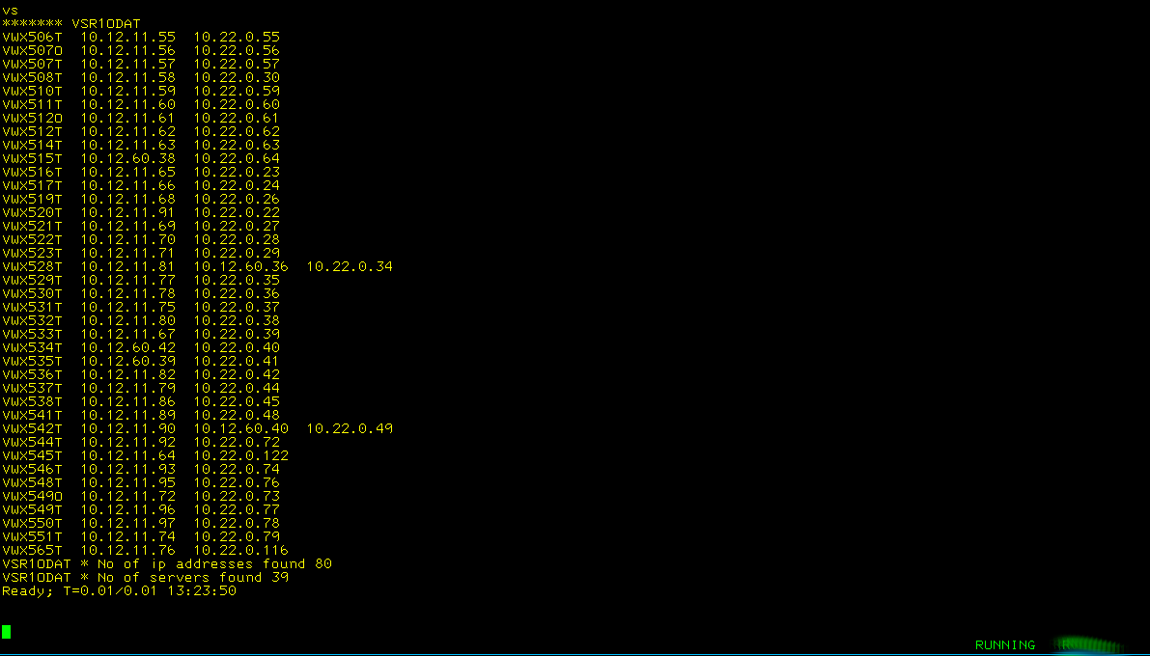
Note: output limited to 1 VSWITCH, see code

Now we do this for all the VSWITCHES and write the output to a file
/* VS Combining the results and write to a file */
/*---------------------------------------------------------------+
| Collect all the switch names |
+---------------------------------------------------------------*/
'PIPE (end ?)',
'cp QUERY VSWITCH ALL', /* Send query 2 CP */
'| pick w1.1 == °VSWITCH°', /* Select these records */
'| change / SYSTEM / ./', /* Replace this */
'| specs w2.1 1', /* Keep 2nd word */
'| specs fs . f2', /* Keep 2nd field */
'| stem vswitch.' /* Store into stem */
/*---------------------------------------------------------------+
| Now process per switch found |
+---------------------------------------------------------------*/
stats.0=0 /* Easy way to initialise a stem */
info.0=0 /* for use with STEM <stem> APPEND */
Do v=1 To vswitch.0 /* Start my loop */
Say '******* 'vswitch.v /* To separate output */
'PIPE (end ?)',
'cp QUERY VSWITCH 'vswitch.v' DETAILS', /* Ask cp for details */
'| frtarget pick anycase w1.2 == /Adapter Connections:/', /* Take it from here */
'| fo1: fanout', /* Duplicate to fo1 label */
'| locate anycase /Adapter Owner/', /* Find these */
'| specs w3.1 1.8 x40 n', /* Keep this from the recordd */
'| j: juxtapose', /* Join records side by side */
'| join keylen 8', /* Join so we see more than 1 IP address */
'| fo2: fanout', /* Send records 2 label fo2 */
'| preface literal * Info for: 'vswitch.v, /* Add a header at start */
'| append literal ', /* Add empty line at end */
'| stem info. append', /* Sadd to stem */
'? fo1:', /* Label connecting to fanout*/
'| strip', /* Remove spaces */
'| inside anycase /UNICAST MAC/ /MULTICAST MAC/', /* Sel. records between these strings */
'| specs w3.1 1 x40 n', /* Keep this bit and add a space */
'| j:', /* Feed records to juxtapose */
'? fo2:', /* Take records from fanout */
'| specs w1.1 1', /* Keep only user id */
'| count lines', /* Count the lines */
'| specs /'vswitch.v' * No of servers found/ 1 w1.1 nw.3 right', /* Add some text */
'| fi: faninany', /* Take records from fi labels */
'| specs w1.1 1.8 w2;* nw', /* Adjust layout */
'| sort', /* Sort records */
'| join keylen 8', /* Join on switch name */
'| stem stats. append', /* Add records to stem */
'? fo2:', /* Take records from fo2 */
'| specs w2;* 1', /* Keep ip addresses */
'| count words', /* Count them */
'| specs /'vswitch.v' * No of ip addresses found/ 1 w1.1 nw.3 right', /* Add text */
'| fi:' /* Connect to faninany */
End v /* To easily identify the loop */
/*---------------------------------------------------------------+
| Write all the output to a file |
+---------------------------------------------------------------*/
'PIPE (End ?)',
'stem stats.', /* Take the stem */
'| preface literal * Statistics:', /* Add a header */
'| append literal ', /* Add empty line */
'| append stem info.', /* Add other stem */
'| > VSWIP FILE A' /* Write to file */
The results in the VSWIP FILE:
* Statistics:
DTCSMAPI * No of ip addresses found 1 * No of servers found 2
IVLF * No of ip addresses found 0 * No of servers found 0
VSR1BHH * No of ip addresses found 45 * No of servers found 45
VSR1ODAT * No of ip addresses found 80 * No of servers found 39
VSR1ZVM * No of ip addresses found 3 * No of servers found 3
XCATVSW1 * No of ip addresses found 0 * No of servers found 0
XCATVSW2 * No of ip addresses found 0 * No of servers found 0

* Info for: DTCSMAPI
DTCSMAPI 10.60.100.100
LOHCOST

* Info for: IVLF

* Info for: VSR1BHH
SHOSHOT 10.11.216.9
XYZ500O1 10.11.216.207
VWX506T 10.11.216.19
VWX507O 10.11.216.20
VWX507T 10.11.216.21
VWX508T 10.11.216.22
VWX510T 10.11.216.23
VWX511T 10.11.216.24
VWX512O 10.11.216.25
VWX512T 10.11.216.26
VWX514T 10.11.216.27
VWX515T 10.11.216.28
VWX516T 10.11.216.29
VWX517T 10.11.216.30
VWX519T 10.11.216.32
VWX520T 10.11.216.33
VWX521T 10.11.216.34
VWX522T 10.11.216.35
VWX523T 10.11.216.40
VWX528T 10.11.216.45
VWX529T 10.11.216.46
VWX530T 10.11.216.47
VWX531T 10.11.216.48
VWX532T 10.11.216.49
VWX533T 10.11.216.36
VWX534T 10.11.216.50
VWX535T 10.11.216.37
VWX536T 10.11.216.38
VWX537T 10.11.216.51
VWX538T 10.11.216.52
VWX541T 10.11.216.55
VWX542T 10.11.216.39
VWX544T 10.11.216.71
VWX545T 10.11.216.107
VWX546T 10.11.216.72
VWX548T 10.11.216.74
VWX549O 10.11.216.70
VWX549T 10.11.216.75
VWX550T 10.11.216.76
VWX551T 10.11.216.77
VWX565T 10.11.216.212
TSTEST01 10.11.216.89
TSTEST02 10.11.216.100
TSTEST03 10.11.216.114
TSTEST04 10.11.216.206

* Info for: VSR1ODAT
VWX506T 10.12.11.55 10.22.0.55
VWX507O 10.12.11.56 10.22.0.56
VWX507T 10.12.11.57 10.22.0.57
VWX508T 10.12.11.58 10.22.0.30
VWX510T 10.12.11.59 10.22.0.59
VWX511T 10.12.11.60 10.22.0.60
VWX512O 10.12.11.61 10.22.0.61
VWX512T 10.12.11.62 10.22.0.62
VWX514T 10.12.11.63 10.22.0.63
VWX515T 10.12.60.38 10.22.0.64
VWX516T 10.12.11.65 10.22.0.23
VWX517T 10.12.11.66 10.22.0.24
VWX519T 10.12.11.68 10.22.0.26
VWX520T 10.12.11.91 10.22.0.22
VWX521T 10.12.11.69 10.22.0.27
VWX522T 10.12.11.70 10.22.0.28
VWX523T 10.12.11.71 10.22.0.29
VWX528T 10.12.11.81 10.12.60.36 10.22.0.34
VWX529T 10.12.11.77 10.22.0.35
VWX530T 10.12.11.78 10.22.0.36
VWX531T 10.12.11.75 10.22.0.37
VWX532T 10.12.11.80 10.22.0.38
VWX533T 10.12.11.67 10.22.0.39
VWX534T 10.12.60.42 10.22.0.40
VWX535T 10.12.60.39 10.22.0.41
VWX536T 10.12.11.82 10.22.0.42
VWX537T 10.12.11.79 10.22.0.44
VWX538T 10.12.11.86 10.22.0.45
VWX541T 10.12.11.89 10.22.0.48
VWX542T 10.12.11.90 10.12.60.40 10.22.0.49
VWX544T 10.12.11.92 10.22.0.72
VWX545T 10.12.11.64 10.22.0.122
VWX546T 10.12.11.93 10.22.0.74
VWX548T 10.12.11.95 10.22.0.76
VWX549O 10.12.11.72 10.22.0.73
VWX549T 10.12.11.96 10.22.0.77
VWX550T 10.12.11.97 10.22.0.78
VWX551T 10.12.11.74 10.22.0.79
VWX565T 10.12.11.76 10.22.0.116

* Info for: VSR1ZVM
CLDCONO1 10.35.4.60
CLDCONO2 10.35.4.61
TCPIP 10.35.4.14

* Info for: XCATVSW1

* Info for: XCATVSW2

Now I want to condense the file a bit by making 2 columns
/* VS Condensing the file a but */
/*---------------------------------------------------------------+
| Collect all the switch names |
+---------------------------------------------------------------*/
'PIPE (end ?)',
'cp QUERY VSWITCH ALL', /* Send query 2 CP */
'| pick w1.1 == °VSWITCH°', /* Select these records */
'| change / SYSTEM / ./', /* Replace this */
'| specs w2.1 1', /* Keep 2nd word */
'| specs fs . f2', /* Keep 2nd field */
'| stem vswitch.' /* Store into stem */
/*---------------------------------------------------------------+
| Now process per switch found |
+---------------------------------------------------------------*/
stats.0=0 /* Easy way to initialise a stem */
info.0=0 /* for use with STEM <stem> APPEND */
Do v=1 To vswitch.0 /* Start my loop */
Say '******* 'vswitch.v /* To separate output */
'PIPE (end ?)',
'cp QUERY VSWITCH 'vswitch.v' DETAILS', /* Ask cp for details */
'| frtarget pick anycase w1.2 == /Adapter Connections:/', /* Take it from here */
'| fo1: fanout', /* Duplicate to fo1 label */
'| locate anycase /Adapter Owner/', /* Find these */
'| specs w3.1 1.8 x40 n', /* Keep this from the recordd */
'| j: juxtapose', /* Join records side by side */
'| change /SLB/XYZ/',
'| change /SLD/VWX/',
'| change /SLT/TST/',
'| change /ONE/SHO/',
'| join keylen 8', /* Join so we see more than 1 IP address */
'| fo2: fanout', /* Send records 2 label fo2 */
'| specs 1;* 1.55', /* Adjust the records to 55 chars */
'| snake 2', /* Make 2 columns */
'| preface literal * Info for: 'vswitch.v, /* Add a header at start */
'| append literal ', /* Add empty line at end */
'| stem info. append', /* Show results */
'? fo1:', /* Label connecting to fanout*/
'| strip', /* Remove spaces */
'| inside anycase /UNICAST MAC/ /MULTICAST MAC/', /* Sel. records between these strings */
'| specs w3.1 1 x40 n', /* Keep this bit and add a space */
'| j:', /* Feed records to juxtapose */
'? fo2:', /* Take records from fanout */
'| specs w1.1 1', /* Keep only user id */
'| count lines', /* Count the lines */
'| specs /'vswitch.v' * No of servers found/ 1 w1.1 nw.3 right', /* Add some text */
'| fi: faninany', /* Take records from fi labels */
'| specs w1.1 1.8 w2;* nw', /* Adjust layout */
'| sort', /* Sort records */
'| join keylen 8', /* Join on switch name */
'| stem stats. append', /* Add records to stem */
'? fo2:', /* Take records from fo2 */
'| specs w2;* 1', /* Keep ip addresses */
'| count words', /* Count them */
'| specs /'vswitch.v' * No of ip addresses found/ 1 w1.1 nw.3 right', /* Add text */
'| fi:' /* Connect to faninany */
End v /* To easily identify the loop */
/*---------------------------------------------------------------+
| Write all the output to a file |
+---------------------------------------------------------------*/
'PIPE (End ?)',
'stem stats.', /* Take the stem */
'| preface literal * Statistics:', /* Add a header */
'| append literal ', /* Add empty line */
'| append stem info.', /* Add other stem */
'| > VSWIP FILE A' /* Write to file */

The condensed content of the VSWIP FILE:
* Statistics:
DTCSMAPI * No of ip addresses found 1 * No of servers found 2
IVLF * No of ip addresses found 0 * No of servers found 0
VSR1BHH * No of ip addresses found 45 * No of servers found 45
VSR1ODAT * No of ip addresses found 80 * No of servers found 39
VSR1ZVM * No of ip addresses found 3 * No of servers found 3
XCATVSW1 * No of ip addresses found 0 * No of servers found 0
XCATVSW2 * No of ip addresses found 0 * No of servers found 0

* Info for: DTCSMAPI
DTCSMAPI 10.60.100.100 LOHCOST

* Info for: IVLF

* Info for: VSR1BHH
SHOSHOT 10.11.216.9 VWX532T 10.11.216.49
XYZ500O1 10.11.216.207 VWX533T 10.11.216.36
VWX506T 10.11.216.19 VWX534T 10.11.216.50
VWX507O 10.11.216.20 VWX535T 10.11.216.37
VWX507T 10.11.216.21 VWX536T 10.11.216.38
VWX508T 10.11.216.22 VWX537T 10.11.216.51
VWX510T 10.11.216.23 VWX538T 10.11.216.52
VWX511T 10.11.216.24 VWX541T 10.11.216.55
VWX512O 10.11.216.25 VWX542T 10.11.216.39
VWX512T 10.11.216.26 VWX544T 10.11.216.71
VWX514T 10.11.216.27 VWX545T 10.11.216.107
VWX515T 10.11.216.28 VWX546T 10.11.216.72
VWX516T 10.11.216.29 VWX548T 10.11.216.74
VWX517T 10.11.216.30 VWX549O 10.11.216.70
VWX519T 10.11.216.32 VWX549T 10.11.216.75
VWX520T 10.11.216.33 VWX550T 10.11.216.76
VWX521T 10.11.216.34 VWX551T 10.11.216.77
VWX522T 10.11.216.35 VWX565T 10.11.216.212
VWX523T 10.11.216.40 TSTEST01 10.11.216.89
VWX528T 10.11.216.45 TSTEST02 10.11.216.100
VWX529T 10.11.216.46 TSTEST03 10.11.216.114
VWX530T 10.11.216.47 TSTEST04 10.11.216.206
VWX531T 10.11.216.48

* Info for: VSR1ODAT
VWX506T 10.12.11.55 10.22.0.55 VWX531T 10.12.11.75 10.22.0.37
VWX507O 10.12.11.56 10.22.0.56 VWX532T 10.12.11.80 10.22.0.38
VWX507T 10.12.11.57 10.22.0.57 VWX533T 10.12.11.67 10.22.0.39
VWX508T 10.12.11.58 10.22.0.30 VWX534T 10.12.60.42 10.22.0.40
VWX510T 10.12.11.59 10.22.0.59 VWX535T 10.12.60.39 10.22.0.41
VWX511T 10.12.11.60 10.22.0.60 VWX536T 10.12.11.82 10.22.0.42
VWX512O 10.12.11.61 10.22.0.61 VWX537T 10.12.11.79 10.22.0.44
VWX512T 10.12.11.62 10.22.0.62 VWX538T 10.12.11.86 10.22.0.45
VWX514T 10.12.11.63 10.22.0.63 VWX541T 10.12.11.89 10.22.0.48
VWX515T 10.12.60.38 10.22.0.64 VWX542T 10.12.11.90 10.12.60.40 10.22.0.49
VWX516T 10.12.11.65 10.22.0.23 VWX544T 10.12.11.92 10.22.0.72
VWX517T 10.12.11.66 10.22.0.24 VWX545T 10.12.11.64 10.22.0.122
VWX519T 10.12.11.68 10.22.0.26 VWX546T 10.12.11.93 10.22.0.74
VWX520T 10.12.11.91 10.22.0.22 VWX548T 10.12.11.95 10.22.0.76
VWX521T 10.12.11.69 10.22.0.27 VWX549O 10.12.11.72 10.22.0.73
VWX522T 10.12.11.70 10.22.0.28 VWX549T 10.12.11.96 10.22.0.77
VWX523T 10.12.11.71 10.22.0.29 VWX550T 10.12.11.97 10.22.0.78
VWX528T 10.12.11.81 10.12.60.36 10.22.0.34 VWX551T 10.12.11.74 10.22.0.79
VWX529T 10.12.11.77 10.22.0.35 VWX565T 10.12.11.76 10.22.0.116
VWX530T 10.12.11.78 10.22.0.36

* Info for: VSR1ZVM
CLDCONO1 10.35.4.60 TCPIP 10.35.4.14
CLDCONO2 10.35.4.61

* Info for: XCATVSW1

* Info for: XCATVSW2

